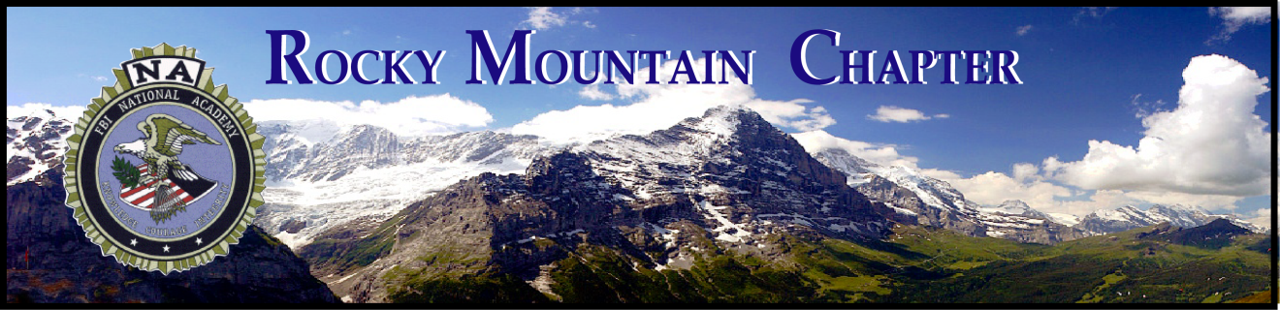

Bill Stanford Memorial Academic Scholarship
Rocky Mountain Chapter FBI National Academy Associates
Application for the 2021 – 2022 academic school year

The Rocky Mountain Chapter of the FBI National Academy Associates offers an educational scholarship program for a graduating high school senior that will be attending an accredited school of higher education. The student may attend a school of higher education of their choice within the United States and may select any field of study. The scholarship will be awarded annually to one recipient in the amount of one thousand dollars ($1,000).

Eligibility Requirements
- Child, step-child, or grandchild of a dues-paying member of the Rocky Mountain Chapter who has graduated from the National Academy Program (attendee or counselor); OR
- A child, step-child, or grandchild of a FBI National Academy graduate that was a member of the Rocky Mountain Chapter who died, was killed, or disabled while employed in law enforcement; AND
- A cumulative high school grade point average of 3.0 or higher.

The chapter provides qualified scholarships as defined in IRS publication 520; scholarship may be used by the student for the tuition and fees paid to enroll and attend an educational institution. Funds are specifically for college tuition, course books and class fees. The scholarship is not for room and board, transportation or any other item that would make the funds taxable under IRS guidelines.

The scholarship will be awarded in September and is intended to be utilized before the end of 2021.

Applications must be received no later than Monday August 2, 2021 to be considered. The president of the Rocky Mountain Chapter will review the applications and recommend the best qualified applicant to the executive board. The executive board will make the final award.

Notice of the results will be sent to all applicants by August 15, 2021. If you are awarded the scholarship, arrangements will be made for reimbursement upon proof of enrollment.

Please direct any questions to the chapter president, Keith McPheeters at kmcpheeters@casperwy.gov. Please submit the completed application using Chief McPheeters’ e-mail address.

2021 Rocky Mountain Chapter FBINAA Bill Stanford Scholarship

Applicant’s name __________________________________________________________
Last First Middle

Permanent mailing address

________________________________________ ___________________________
Number, street, apartment # City, State, Zip

( ) _________________________ ____________________________________
Home Phone # Email address

Name of relative who qualifies you for eligibility ___________________________________

Is the relative a current dues-paying member of the Rocky Mountain Chapter? Yes No

Was the relative killed or disabled while employed in law enforcement? Yes No

Relative’s Session # ______ Relationship to student _______________________________

Are you currently a high school senior? Yes

What high school do you attend _______________________ City ___________ State ____

Current cumulative grade point average ______ / 4.0

During the 2021-2022 academic year, what accredited college will you attend?

Name of school ____________________________________ City ___________ State ____

Describe your scholastic distinctions or honors you earned in grades 9 – 12th. Include any college level courses that you have completed.
Scholastic distinction | 9th | 10th | 11th | 12th | Describe/Details
Sample: AP & Honors class - Physics |  | XX |  |  | Won school prize for best paper
Essay
The following section is completed by the Rocky Mountain Chapter member (if alive):

I recommend __________________________, who is a relative of my family. I believe that he/she will be an excellent recipient.

____________________________________ _______ ___________
Name Session # Date

All applicants must include an essay that may be up to, but not more than, one single sided 8 ½” x 11” page. It must be typed and double spaced. Include your name in the upper right corner of the page.

Topic: Education is an important component of the business world. Explain, in your own words, what a college degree means to you in your personal and business life.

I certify that the information in the application is accurate and complete to the best of my knowledge. Falsification of any information will cause disqualification.

If selected as a recipient, I authorize release of my name and likeness to be used for publicity purposes.

_________________________________ _________
Applicant’s signature Date

Parental agreement and signature is required when parent(s) are providing support and/or contributing to the college costs.

_________________________________ _________
Parent or guardian signature Date

Required attachments:

Official high school transcript of grades
Completed essay

