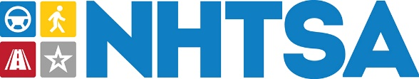
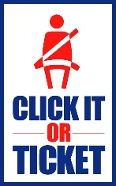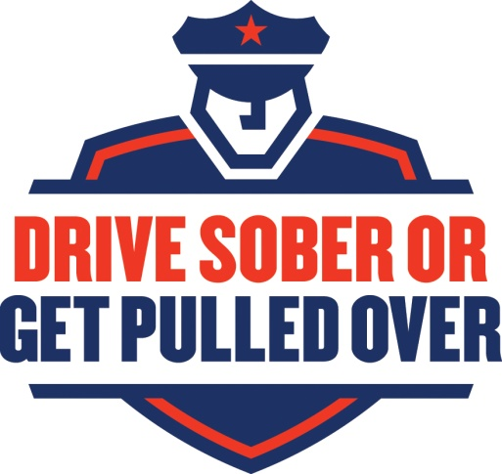

Part-Time Law Enforcement Liaison Position
We are currently seeking an individual for the position of Law Enforcement Liaison (LEL) for the Region 8 Office of the National Highway Traffic Safety Administration (NHTSA)
This position will be a sub-contractor position that will be responsible for representing the NHTSA Region 8 States that include Colorado, Wyoming, North Dakota, South Dakota, Nevada and Utah. It will require extensive travel throughout the region.
DESCRIPTION
This will be a sub-contractor position responsible for ensuring that effective, coordinated, and meaningful traffic enforcement occurs that contributes to a reduction in crashes, injuries, and fatalities. The National Highway Traffic Safety Administration Region 8 Office requires support to establish and maintain contact with law enforcement agencies within their States. To accomplish these efforts, law enforcement agencies need information, training, and technical assistance to be able to fully support NHTSA traffic enforcement priority programs. This Law Enforcement Liaison must be a former law enforcement commander or agency head with a traffic enforcement background.
Primary duties include:
- Engaging in regular contact with law enforcement agencies within Region 8 to increase and expand traffic safety enforcement through participation in high visibility enforcement campaigns and by means of sustained general traffic enforcement throughout the year.
- • Making presentations within the States or at Regional meetings on traffic safety and priority program issues.
- Supporting States in organizing and conducting law enforcement-related events related to crackdowns and mobilizations at the National, State or local level.
For questions or further information contact:
Bill Sullivan, Project Manager 913-208-5714 bsully@sbcglobal.net

